Dilated cardiomyopathies (DCM) are a major cause of heart failure worldwide and genetic forms of DCM account for ~30% of cases. DCM is characterized by left ventricular dilation and reduced systolic function. *MYH7*, which encodes β-cardiac myosin (M2β) and is the molecular motor that powers contraction in human ventricular myocytes, is commonly mutated in DCM. During systole, muscle force and power are determined by several factors; 1) the myosin ATPase cycle (Fig. 1A), 2) intrinsic force generation of individual myosin molecules (Fig. 1B), 3) and the calcium-dependent recruitment of the ensemble of myosin motors (Fig. 1C). In addition, striated muscle myosins are believed to exist in an auto-inhibited, super-relaxed (SRX) state that is in equilibrium with a disordered (DRX) state capable of generating force upon actin binding (Fig. 1C). Thus, the impact of DCM mutations on the SRX/DRX ratio (Fig. 1A) can dramatically impact the number of available myosin heads in muscle and thus maximal force and power. ***We hypothesize that DCM mutations reduce muscle force and power by decreasing the intrinsic motor properties, stabilizing the SRX state, and/or decreasing calcium-dependent recruitment of myosin heads.*** This multi-PI proposal combines our expertise in enzymology (Yengo), structural biology (Craig), single molecule biophysics (Warshaw), bioengineering (Sivaramakrishnan), and muscle fiber computational modeling (Campbell) to characterize the molecular structure and function of expressed human cardiac myosin with DCM-causing mutations.

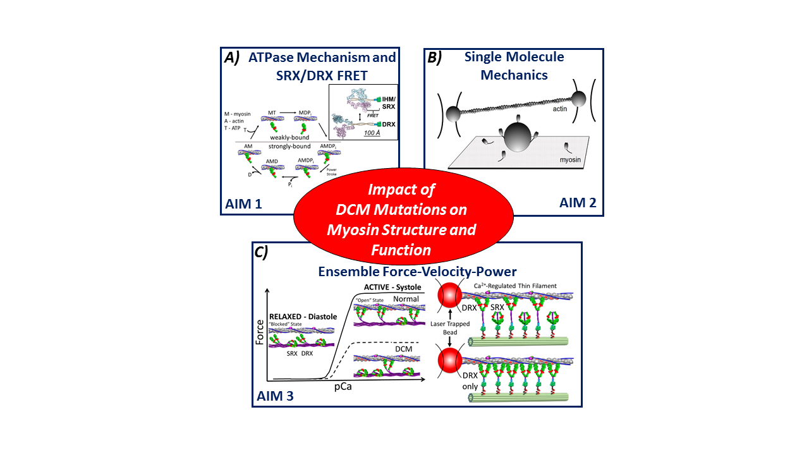**Figure 1.** Summary of Specific Aims.

**Aim #1: Define the impact of DCM mutations on the human beta-cardiac myosin ATPase cycle, force-producing power stroke, and ability to transition into and out of the auto-inhibited SRX state. *We hypothesize that DCM mutations impair one or more key transitions in the ATPase cycle that define the duty ratio (fraction of ATPase cycle that myosin is strongly bound to actin), myosin power stroke, and/or the SRX state formation/stabilization.*** We will express five DCM M2β point mutations, based on their structural location in critical domains of the myosin molecule, predicted to impact specific steps in the ATPase cycle or the potential for forming the SRX state. The effect of these DCM mutations on the pre- and post-power stroke conformations using FRET probes will detect potential alterations in the force-generating myosin lever arm swing. We will define the SRX state stability in mutants using a FRET biosensor that reports the auto-inhibited conformation (interacting heads motif, IHM), which will be confirmed directly by electron microscopy.

**Aim #2: Determine the impact of DCM mutations on M2β’s molecular force generation at the single molecule level. *We hypothesize that DCM mutations can impact the intrinsic force generating capacity of individual myosin motors.*** We will use single molecule optical tweezers to characterize the impact of the DCM mutants on the mechanical properties of individual myosin molecules. The key mechanical parameters including, step size, intrinsic force, and load-dependent detachment will be measured with single human beta-cardiac myosin molecules incapable of forming the SRX state in the presence of native cardiac thin filaments.

***Aim #3:* Define the impact of DCM mutations on ensemble force and power generation when assembled into designer thick filaments. *We hypothesize that DCM mutations impact myosin recruitment during calcium dependent thin filament activation which alters ensemble force, velocity, and power.*** We will use innovative DNA origami techniques to create “designer” myosin thick filaments so that the spatial orientation and number of myosin motors that contribute to force are defined. Comparison of M2β DCM mutants with wildtype constructs will define the impact of mutations on myosin recruitment and force generation in a calcium-dependent manner using native cardiac thin filaments. A computational model of muscle contraction, which includes parameters directly measured in Aims #1 and #2, will be used to simulate contractile parameters and compared to experiments, thus allowing us to predict how myosin properties impact systolic contractions in the heart.

**Upon completion of this proposal, we will have determined the detailed molecular mechanisms of myosin motor impairment in DCM-associated mutations, which will serve as a foundation for designing and testing therapeutic strategies. We will also reveal fundamental aspects of cardiac myosin structure, function, and regulation important for understanding normal cardiac muscle physiology.**